1. An algorithm breaks down a bigger problem into smaller sub problems and then solves them individually
2. Merge sort, quicksort, binary search
3. Camscanner file on Github
4. Quicksort is better used on small arrays than mergesort because mergesort needs a temporary array and therefore additional storage space to do its sorting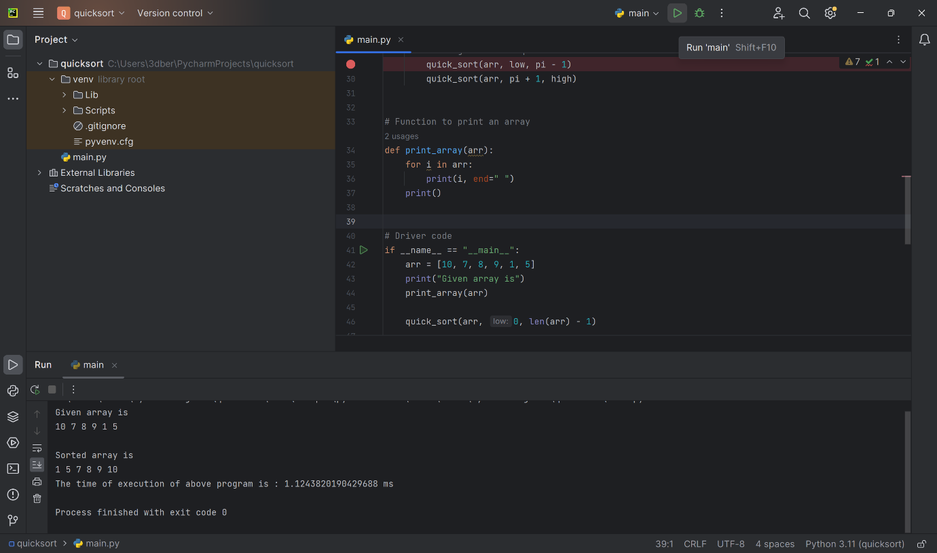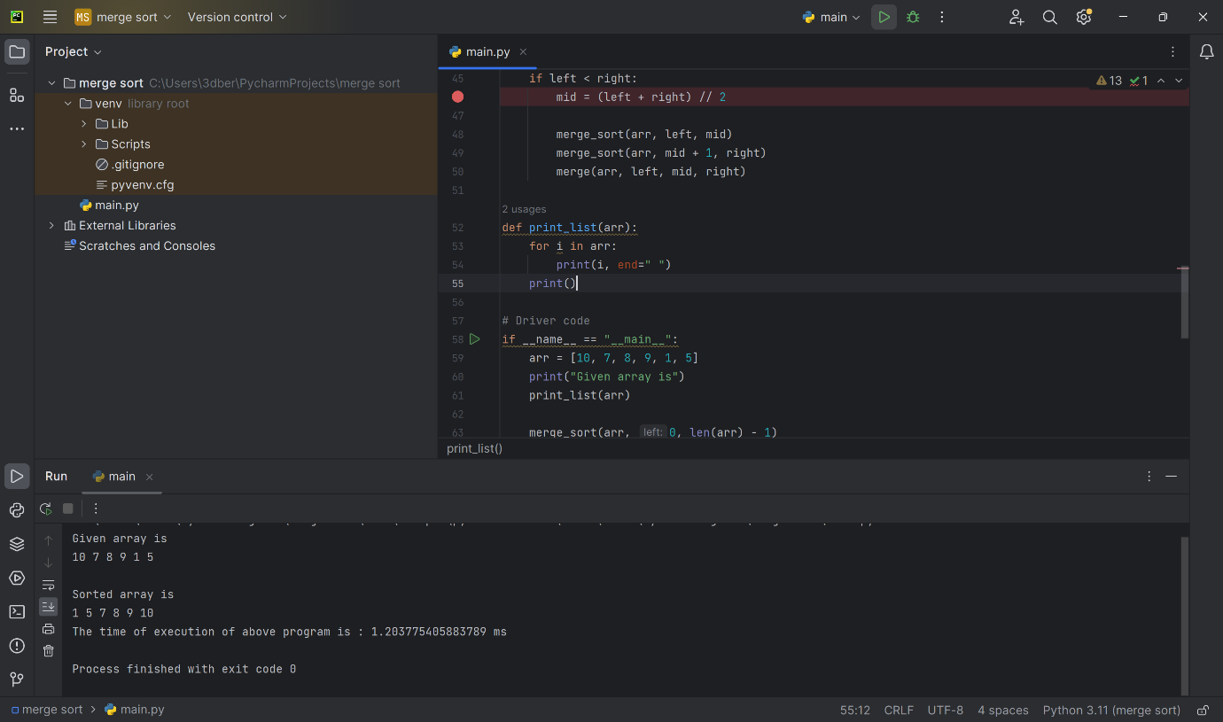
5. Heapsort should be used when the array is too big for other sorts to function, as heapsort takes less memory space than other sorts to run especially for larger arrays